**QSMART – POCKELS CELL REPLACEMENT**

**PROCEDURE**

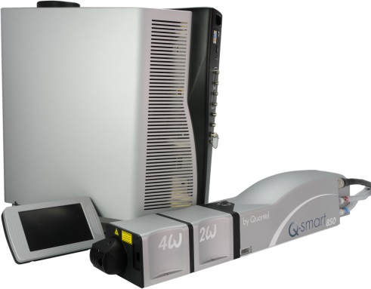

**Toolkit:**

Screwdrivers

Allen keys

Cover interlock holder RM100016A

Energy meter

Photodiode

Analyzer / polarizer 1/OUT/0019

Upgrade soft Q-Smart tool SM020006A

**System**: QSMART

|  |  |  |  |  |  |  |
| --- | --- | --- | --- | --- | --- | --- |
| |  |  | | --- | --- | | **SM010348A** | **Q-SMART POCKELS CELL ASSY** | |  |  |  |  |

**Purpose**: This document details how to change the pockels cell

|  |  |  |
| --- | --- | --- |
| Revision | date | modification |
| Initial issue | July 4, 2014 |  |
|  |  |  |
|  |  |  |
|  |  |  |

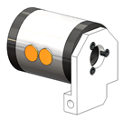

# 1 DISASSEMBLING

* Turn the system off
* Disconnect cables and water hoses from the side of the laser head
* Remove the laser head cover.
* Remove the side plate (7 BHC 3x6)

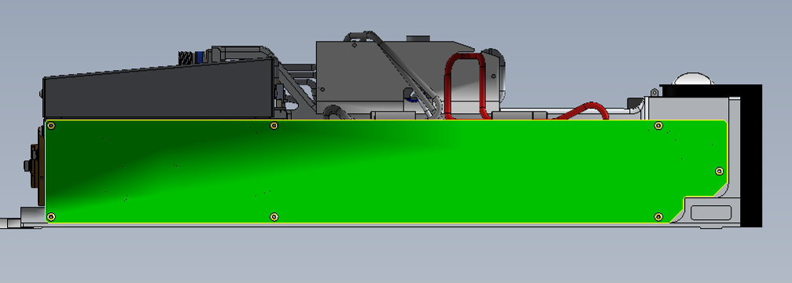

* Remove the ground wire (1), remove the power connector on the card Q Switch (2) and remove the connectors on the pockels (3)

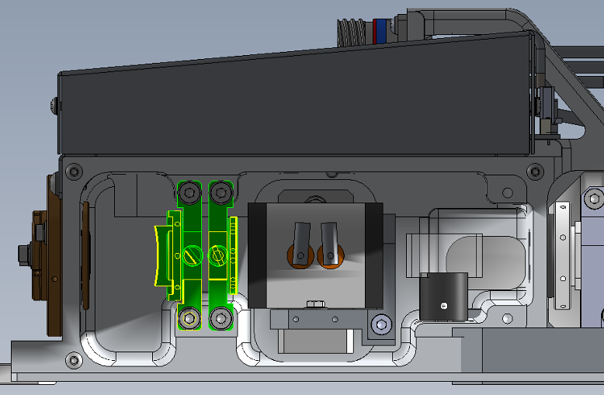

Position1 et 2

Position3

* Remove the unit from the foundry (3 screws)

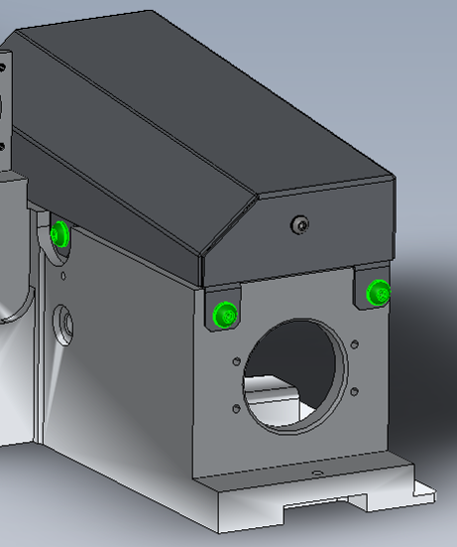

Remove the quarter wave plate mount (and cylindrical lens if present)

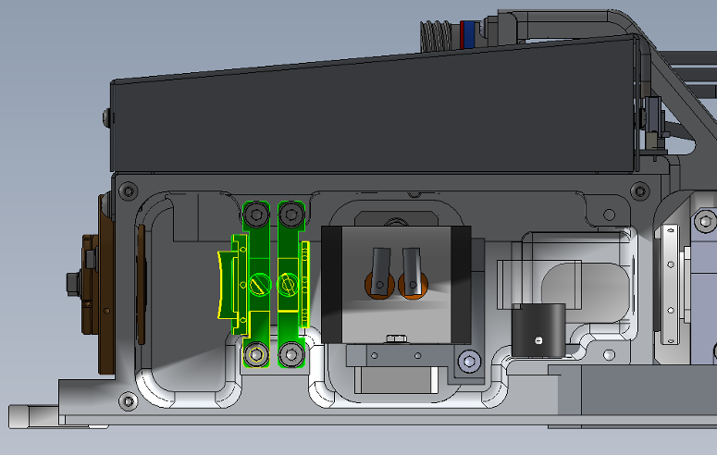

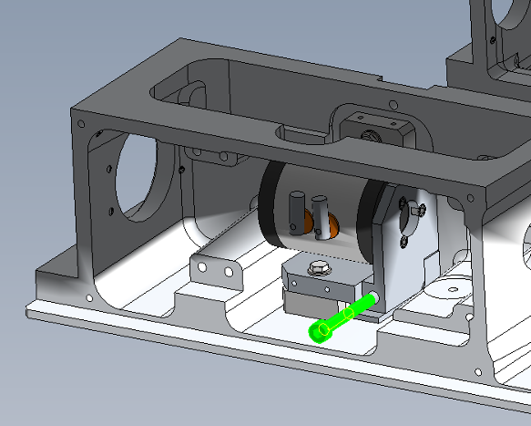

* Remove the Pockels cell (1 CHC 4x30)

# 2 REASSEMBLING AND ALIGNMENT

M1

Pin hole

Source He-Ne

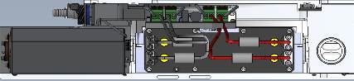

M2

* Check the good alignment of the He-Ne (height=43mm): the pin hole must be in place.
* You have to check with a target near field (adjust M1) and far field (adjust M2)



* Fasten the Pockels cell with CHC screws 4x30.
* Put the Analyzer/Polarizer 1/OUT/0019 on each side of the Pockels like shown.

Mire

Polarizer r*

Rod

Pockels cell

Analyzer

10 cm

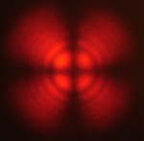

* You should see a Maltese cross when the analyzer and the polarizer are perpendicular.
* Adjust the two axes of the support so the red dot (reference beam) passes through the center of the cross.
* After the adjustment, tighten the screws to block the movement of the pockels.
* Replace pockels housing with 3 screws and connect the power wires on the cell.

|  |  |  |
| --- | --- | --- |
| 1.00 | V/BHC-M0306A4 | BHC 3X6 SCREW |
| 1.00 | R-DEC-D03-- | LOCKING 3 WASHER |



* Fasten the unit to the foundry (3 screws BHC4x10 + 4 ZU4 washers)
* Replace the ground wire (1), connect the power connector on the card Q Switch (2) and the connectors on the pockels (3)



Position1 et 2

Position3

# 3 LASER ADJUSTMENT

*Refer to the Laser Adjustment procedure*

* Close the Laser head and put warranty stickers   
  *Refer to "LH-Warranty Labels"*